Step 1. Installing the game at <https://cuuam.gosu.vn/tai-game.html>

Step 2. Update the game to the newest version, created an account and log-in to the game, then exit

Step 3. Extract challenge’s files, copy and paste it to the game folder

Step 4. Re-login

Step 5. Now press “Num 3”, you will see

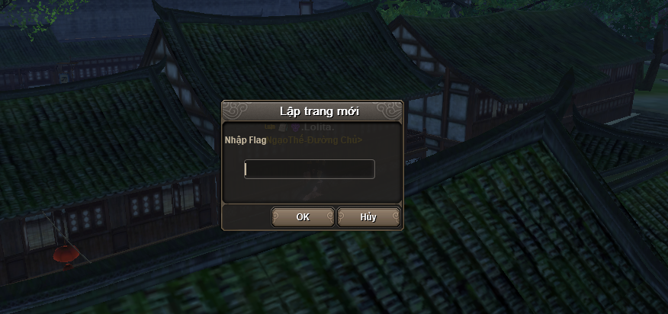

Step 6 : Type in the correct flag and good luck, have fun ;)